Dear treatment provider:

Thank you for assisting our mutual client meet the North Carolina DWI
requirements:

When a person receives a DWI in North Carolina (no matter how far back it was), the
client is required to have a comprehensive substance use assessment and complete
wither education or treatment. Please send a copy of the assessment and
recommendations for either education or treatment. No education or treatment is
NOT an option for North Carolina. The results of your assessment will determine
the level of care. No diagnosis will require an education program .5 ASAM level.
Severe diagnosis required a long term program of not less than 60 days. North
Carolina will accept your first offenders program if this is the participants’ first
offense. If you have any questions regarding placement criteria, please feel free to
give us a call. North Carolina does recognize the Prime For Life program. If a short
term out-patient treatment is recommended, North Carolina requires that it is no less
than 20 hours. North Carolina does recognize any state approved programs from your
state. The substance use education or treatment needs to be completed to satisfy
North Carolina’s requirements to release the hold on the driving privileges.
When client completes the education or treatment, North Carolina DMV requires that
the facility or you to mail or fax to us a letter or certificate stating the following:
Name of the program, Start date, completion date and the number of hours of
treatment/education completed
Breathe., LLC  52 Union Street S. Suite 27  Concord, NC 28025  Tel 704-782-3050 Fax 704-973-0992  breathecharlotte@gmail.com  www.breathewellnesscenternc.com | 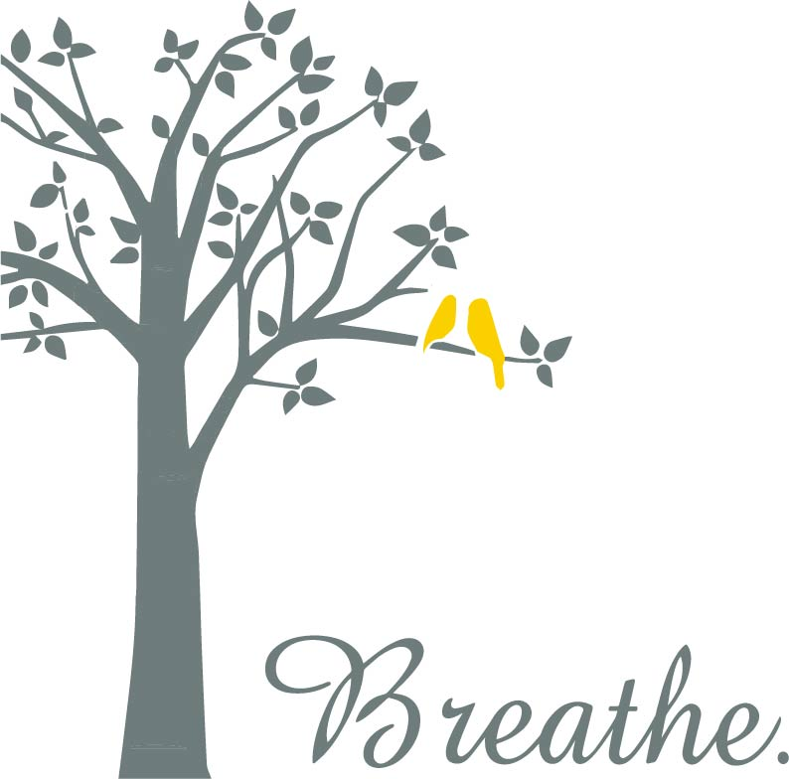

Sincerely,
Alanna Brewton, MS, LCAS
Clinical Director

